

This template is provided to give authors a basic shell for preparing your manuscript for submittal to an SPE meeting or event. Styles have been included to give you a basic idea of how your finalized paper will look before it is published by SPE. All manuscripts submitted to SPE will be extracted from this template and tagged into an XML format; SPE’s standardized styles and fonts will be used when laying out the final manuscript. Links will be added to your manuscript for references, tables, and equations. Figures and tables should be placed directly after the first paragraph they are mentioned in. The content of your paper WILL NOT be changed.

Probability Approach to Casing Design Using Monte Carlo Simulation

Copyright 2020, Society of Petroleum Engineers

This paper was prepared for presentation at the Nigeria Annual International Conference and Exhibition held in Lagos, Nigeria, 10–12 August 2020.

This paper was selected for presentation by an SPE program committee following review of information contained in an abstract submitted by the author(s). Contents of the paper have not been reviewed by the Society of Petroleum Engineers and are subject to correction by the author(s). The material does not necessarily reflect any position of the Society of Petroleum Engineers, its officers, or members. Electronic reproduction, distribution, or storage of any part of this paper without the written consent of the Society of Petroleum Engineers is prohibited. Permission to reproduce in print is restricted to an abstract of not more than 300 words; illustrations may not be copied. The abstract must contain conspicuous acknowledgment of SPE copyright.

Abstract

Casing design plays an important role in the successful drilling of a well and accounts for a substantial percentage of well costs. The goal of casing design is to get an optimal design that will withstand the stress and other factors that affect the casing throughout the lifetime of the well. The conventional approach to casing design uses a deterministic working stress design (WSD), where minimum strength requirements of the casing are determined by comparing casing strength to the magnitude of severe accidental loads that may occur during the lifetime of the well. Uncertainties in the load and strength of the casing are accounted for by multipliers called safety factors (SFs) that are mostly based on experience and do not reflect the probability or consequence of the different casing failure modes. This approach may result in overly conservative casing designs, or design requirements for severe conditions that are expensive, leading to higher well costs.

In this paper, the Monte Carlo Simulation (MCS) method is applied to casing design, where uncertainties in casing loads are considered explicitly by assigning probability distributions to safety factors that affect design variables and parameters. As the MSC method predicts the casing safety factor probability, it gives a better view of the real uncertainties involved in the design. Acceptable probabilities of casing safety factor can be selected based on the cost and operating conditions the casing will undergo; thus, a probability approach to casing design is more flexible as it allows an explicit uncertainty-consistent designs compared to traditional working stress designs.

**Keywords** – Casing Design, Probability Density Function, Monte Carlo Simulation, Cumulative Distribution Function, Statistical Analysis.

Introduction

Casing is the major structural component of a well. Casing is needed to maintain borehole stability, prevent contamination of water sands, isolate water from producing formations, and control well pressures during drilling, production, and workover operations.¹ Designing of casing string requires knowledge of the operating conditions the casing will undergo as well as the concepts related to pipe properties.² While underdesigned casings are prone to failure at their early stage of operation, the overdesigned casing system adds a higher cost to the total project expense.3 Therefore, optimization of the casing design is essential to keep the casing cost minimal and the casing functioning properly.

The conventional approach to casing design uses a deterministic working stress design (WSD), which is based on multipliers called safety factors (SFs).4 The primary role of a safety factor is to account for uncertainties in the design variables and parameters. The magnitude of the SF is usually based on experience. Different companies use different acceptable SFs for their casing design presented in the relevant guidelines and recommendations, such as American Petroleum Institutes (API). Experience as shown that, SFs give little indication of the probability of failure of a given casing, as they do not explicitly consider the randomness of the design variables and parameters. Some other limitations of this approach are listed in 4.

Real-world problems involve uncertainties.5 To face engineering problems under uncertainty, it is necessary to prearrange proper probabilistic models capable of providing the quantification of such uncertainty, so that it can be taken into account in the process of decision making for engineering planning and design.6

Several studies on the probability approach to casing design have been published. 7 found that material yield limit is the most inﬂuential random variable in failure probability, followed by the wall thickness. The casing grade was also found to provide signiﬁcantly impact in the serviceability limit state. Some high failure probability values are noticed in K55 steel grade. 8 examined the probabilistic forecast workflow for WSD key output "Minimum Absolute Safety Factor". Using Monte-Carlo random sampling method. 9 obtained a probability of casing failure with different pressure and a relationship between safety factor and the probability of casing failure. It was shown that casings of different types and under the effect of different external loads have similar safety coefficient and different probabilities of failure.

The objective of this paper is to apply different probability distributions to determine the design load statistical values, with a Monte Carlo Simulation methodology applied for the selection of the most appropriate safety factor. Two probability distributions models are simulated using a C# programming language. Distributions used in the analysis are Uniform and Triangular probability distribution models.

Monte Carlo Simulation

Monte Carlo Simulation (also known as the Monte Carlo Method) is a way to account for uncertainties in analysis. The method finds all possible outcomes of your decisions and assesses the impact of risk. The method consists of generating $r$ random possible events and the number of failure events $n_{r}$. The failure probability can be estimated mathematically as

$P_{f}=\frac{n_{r}}{r} (when P\left(X\right)≤0)$ 1

The random working stress loads are defined by generating $r$ random statistical values for each random safety factor assumed in the analysis, by following the respective distribution model. By its nature, Monte Carlo provides very accurate results, since an adequate number of simulation is performed.

Random Number Generation

The C# algorithm in 10 is based on a pseudorandom number generator that produces a sequence of numbers $R$ that are uniformly distributed in the half-open interval [0,1]. These random variates $R$ are then transformed through some algorithm to create a new random variate having the required probability distribution. With this source of uniform pseudo-randomness, the realization of any random variable can be generated.11

In this study, the casing design safety factor, SF, is taken as a continuous random variable. The Cumulative Distribution Function (CDF), $F_{R}\left(r\right),$ of the random variable $R$ provides the probability that $R$ asumes values lower than or equal to a specific value $r$ $F_{R}\left(r\right)=P\left[R≤r\right],$ while the Probability Density Function (PDF), $f_{R}\left(r\right),$ of the random variable, $R$ provides the density of probability of $R,$ i.e. $f_{R}\left(r\right)dr$ provides the probability that $R$ assumes values in the interval $\left[r,r+dr\right]:f_{R}\left(r\right)dr=P\left[r<R≤r+dr\right]$.

Selection of Adequate Probability Density Functions

To obtain the more adequate representation of the actual probability distribution of the casing design safety factor, the two following distributions are selected and considered in the statistical analysis reported in this research work:

1. the Continous Uniform distribution
2. the Triangular distribution.

The Uniform distribution has been selected because it best characterizes the casing design safety factor random variable provided by API. Where all values have an equal chance of occurrence.12 While Triangular distribution is based on experience, where values around the most likely (mode) safety factor, can be defined together with the minimum and maximum values calculated from API BULL 5C3.

Probability Distributions of Casing Design

Casing design safety factors data can be obtained through experience or from relevant guidelines and recommendations, such as American Petroleum Institutes (API). The tables in API 5C2 use formulae defined in API 5C3 (Superseded by ISO 10900). Understanding the relevant safety factors to apply requires an understanding of these formulae, as well as the manufacturing tolerances defined in API 5CT.13 In this study, two statistical probability distributions were applied to the casing design safety factor data, with the distributions fitted using the Monte Carlo simulation (MCS) method. The formulations of various distributions presented in this section follow 14 and 15.

Continuous Uniform Distribution

The continuous uniform distribution also referred to as the rectangular distribution, is commonly used to represent an equal chance of occurrence. The distribution is a family of symmetric probability distributions and its PDF and CDF functions are given in equations 3 and 5 below.

The uniform density function on the interval [a, b] is the constant function defined by

$f\left(x\right)=\frac{1}{b-a}$ 2.

Its graph is a horizontal line:

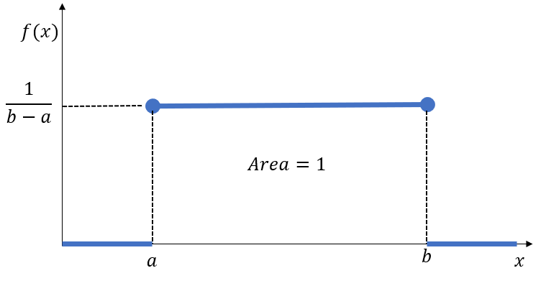 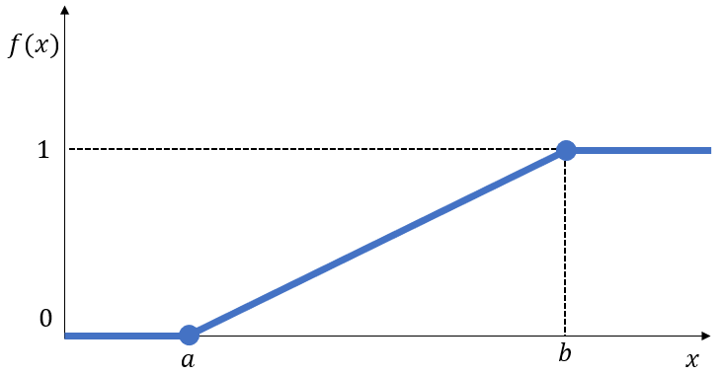

Figure 1. Uniform probability density function. Figure 2. Uniform cumulative distribution function.

So,

$f\left(x\right)=\left\{\begin{aligned}\frac{1}{b-a}, &a≤x≤b , a>0 \\ 0, &otherwise\end{aligned}\right.$ 3

The cumulative distribution function on the support $a<x<b$ is defined by

$F\left(x\right)=\int_{a}^{x}{\frac{1}{b-a}dw=\left[\frac{w}{b-a}\right]}{x \atop a}=\frac{x-a}{b-a}$ 4

So,

$F(x)=\left\{\begin{aligned}0, x≤a \\ \frac{x-a}{b-a}, a<x<b \\ 1, x≥b \end{aligned}\right.$ 5

If a random variable X admits a uniform density function, we say that X is uniformly distributed, or that X has the uniform distribution.

Triangular Distribution

The Triangular distribution is a continuous probability distribution whose parameters are defined within the limits of the interval [0,1]. This distribution is suitable for modelling processes that have a less conservative estimate of uncertainty. The application of the triangular distribution is based on the assumption that maximum and minimum values of the distribution are known and the mode of the triangular distribution occurs at zero. Its PDF and CDF functions are given in equation 6 and 9.

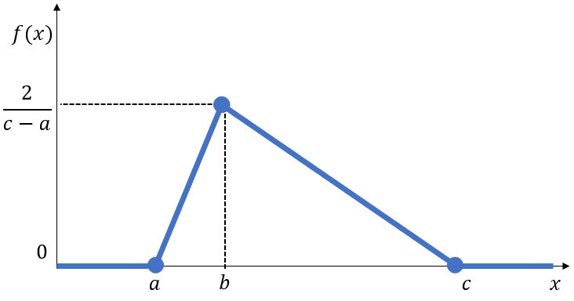 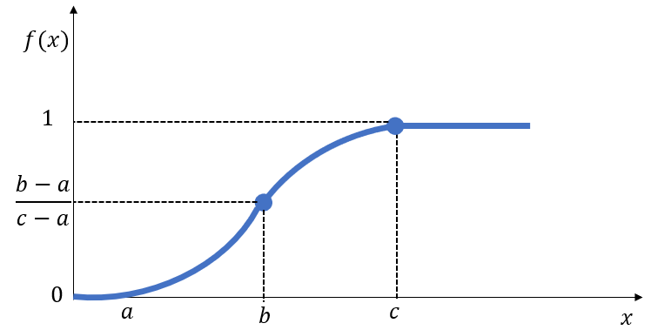

Figure 3. Triangular probability density function. Figure 4. Triangular cumulative distribution function.

$f(x)=\left\{\begin{aligned}0, x<0 \\ \frac{2\left(x-a\right)}{\left(b-a\right)\left(c-a\right)}, a≤x<b \\ \frac{2}{c-a}, x=b \\ \frac{2\left(c-x\right)}{\left(c-a\right)\left(c-b\right)}, b<x≤c \\ 0, c<x\end{aligned}\right.$ 6

The CDF of $X∼$ triangular (a, b, c) on $a<x≤b$ is

$F\left(x\right)=\int_{a}^{x}{\frac{2\left(t-a\right)}{\left(b-a\right)\left(c-a\right)}dt}=\frac{{\left(x-a\right)}^{2}}{\left(b-a\right)\left(c-a\right)}$ 7

The CDF on $b<x<c$ is

$F\left(x\right)=\frac{b-a}{c-a}+\int_{b}^{x}{\frac{2\left(c-t\right)}{\left(c-a\right)\left(c-b\right)}dt}=1-\frac{{\left(c-x\right)}^{2}}{\left(c-a\right)\left(c-b\right)}$ 8

So,

$F\left(x\right)=\left\{\begin{aligned}0, x≤a \\ \frac{{\left(x-a\right)}^{2}}{\left(b-a\right)\left(c-a\right)}, a<x≤b \\ 1-\frac{{\left(c-x\right)}^{2}}{\left(c-a\right)\left(c-b\right)}, b<x<c \\ 1 , x≥c\end{aligned}\right.$ 9

Goodness of Fit (GOF) Test

Several statistical tests can be used to compare the actual empirical cumulative distribution function (CDF) of the data Fe(x) with the cumulative distribution used to characterize the data Ft(x). The tests used for cumulative distributions are the Anderson-darling and Cramer von-Mises tests.

Anderson Darling Statistic

Anderson Darling goodness of fit test is a modification of the Kolmogorov-Smirnov (K-S) test by providing more emphasis on the tails of the distribution. The Anderson Darling test is used to compare the fit of an observed cumulative distribution function to an expected cumulative distribution function.

The Anderson-Darling statistic (A2) is defined as:

$A^{2}=n\int_{-∞}^{∞}{{\left(F_{e}\left(x\right)-F_{t}\left(x\right)\right)}^{2}ω\left(x\right)dF_{t}(x)}$ 10

$ω\left(x\right)={\left[F_{e}\left(x\right)(1-F_{t}\left(x\right))\right]}^{-1}$ 11

Where:

$ω\left(x\right)$ is the weighting function and $F$ is the cumulative distribution function of the specified distribution.

When the Anderson Darling test’s weighting function 𝜔(𝑥) = 1 the test statistic is equal to the Cramer von-Mises Statistic. The addition of this weighting function allows the test to place more emphasis on the tails of the distributions tested.

Cramer von-Mises Statistic

The Cramer von-Mises statistic integrates across the square of CDF differences. This allows for a comparison of the fit along with the entire distribution, unlike the Kolmogorov Smirnov statistic which is influenced by a single absolute maximum.

$ω^{2}=\int_{-∞}^{∞}{{\left[F_{e}\left(x\right)(1-F_{t}\left(x\right))\right]}^{2}dF_{t}(x)}$ 12

Additionally, an approximation for the p-value of the Cramer von-Mises test can be computed directly using Monte-Carlo simulations.16 This approach was employed for this study.

Case Study

Data

This study considered a real land well data set for casing design provided by 17. The well data are given in Table 1. These data are required to calculate the burst and collapse loads that would be used to select an appropriate casing for the surface, intermediate and production string of this land well.17

Table 1: Casing Design data from a real land well

|  |  |  |  |  |  |  |
| --- | --- | --- | --- | --- | --- | --- |
| Hole size depth (ft) | | Driven 100 | 26" 3000 | 17½" 6000 | 12½" 10000 | 8½" 9500 - 12000 |
| Casing size (in.) | | 30" | 20" | 13⅜" | 9⅝" | 7" |
| Expected mon/max. pore pressure grad. (PPG) | | - | 8.6 | 8.6/9.5 | 9.5/11.0 | 11.0/14.0 |
| Expected LOT pressure grad. (PPG) | | - | 13.0 @ 3000' | 16.0 @6000' | 16.5 @10000' |  |
| Mud-weight (PPG) | | - | 9.0 | 11.0 | 14.0 | 15.0 |
| Cementing data | TOC | - | Seabed | 4300 | 7500 | 9500 |
| Lead slurry (PPG) | - | 13.5 | 13.5 | 13.5 | 15.88 |
| Tail slurry (PPG) | - | 15.88 500ft | 15.88 500ft | 15.88 500ft | 15.88 500ft |
| Mix-Water (PPG) | - | 8.5 | 8.5 | 8.5 | 8.5 |
| Potential hole problems | | - | Unconsolidated Caving Sloughing | Possible lost circ. | Unstable shales | Over-pressured shales |

**Assumptions:**

Gas Density above 1000ft: 0.1psi/ft

Design factor(burst): 0.65, 1.0 and 1.1

Design factor(collapse): 0.85, 1.0 and 1.125

**Production tests data:**

Well test completion fluid density: 8.60ppg

Test packer depth: 11000ft TVD KRB

Test perforation depth: 11250ft TVD KRB

Pressure at top of perforation: 14.0ppg

Well test shut-in fluid gradient:10.15psi/ft

Result and Discussion

To facilitate the probabilistic analysis, the net loads presented in 17 was applied. Probability distributions were determined for selecting an appropriate safety factor that would be used to calculate casing design burst and collapse loads; for a demonstration purpose, surface casing string was considered, as shown in Figures 5 and 6.

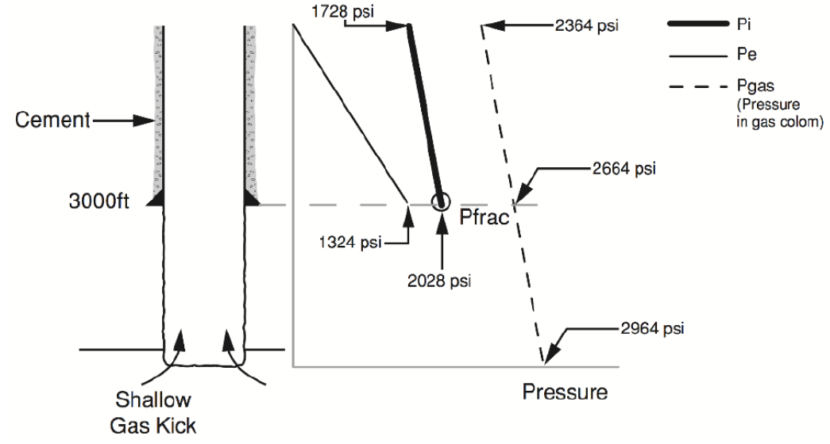 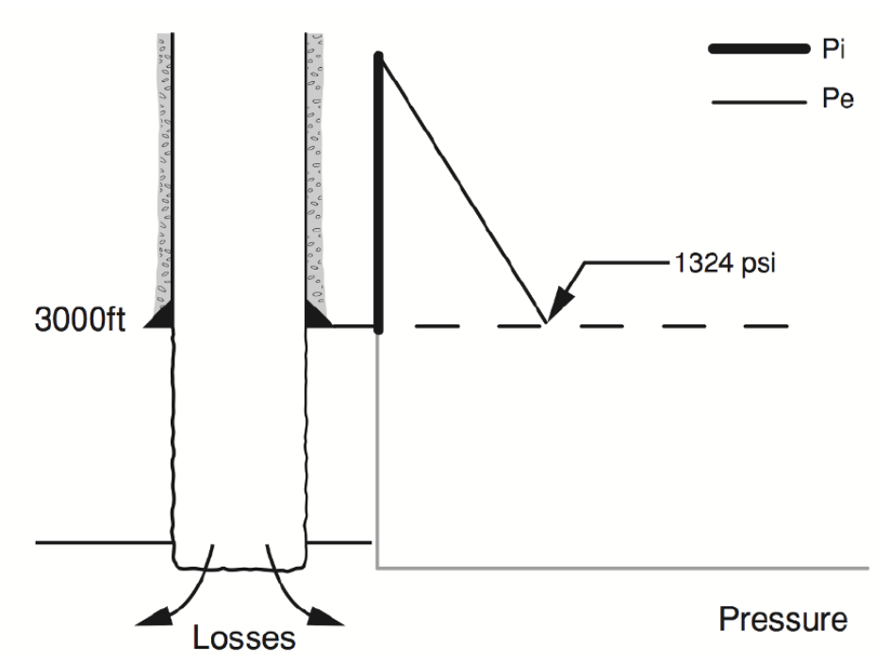

Figure 5. Burst Design – Drilling.17  Figure 6. Collapse Design – Drilling.17

Triangular Distributions

The triangular distribution presented well the safety factor and design load (Figure 7, 8, 9 and Figure 10). The plots do reveal deviation towards the tails of the distribution, implying the region in which the goodness of fit test is neglecting the distribution.

Anderson Darling goodness of fit test was applied to the design loads to further support the visual representation. The results in Table 2 indicate the effective significance level in which the design load is possible and more stable around the estimate. These results support the visual inspection of the PDF and CDF plots for the suitability of the applied distribution.

Table 2: Summary of burst and collapse loads for triangular distribution

|  |  |  |  |  |  |
| --- | --- | --- | --- | --- | --- |
|  | | Burst load | | Collapse load | |
|  | | Surface | Casing shoe | Surface | Casing shoe |
| Depth (ft) | |  | 3000 |  | 3000 |
| External load (psi) | | 0 | 1342 | 0 | 1342 |
| Internal load (psi) | | 1728 | 2028 | 0 | 0 |
| Net load (psi) | | 1728 | 686 | 0 | 1342 |
| Working stress design load (psi) | | 1901 | 755 | 0 | 1342 |
| Probability  (Confident interval) | P90 (psi) | 1281 | 509 |  | 1223 |
| P50 (psi) | 1391 | 555 |  | 1274 |
| P10 (psi) | 1521 | 607 |  | 1326 |

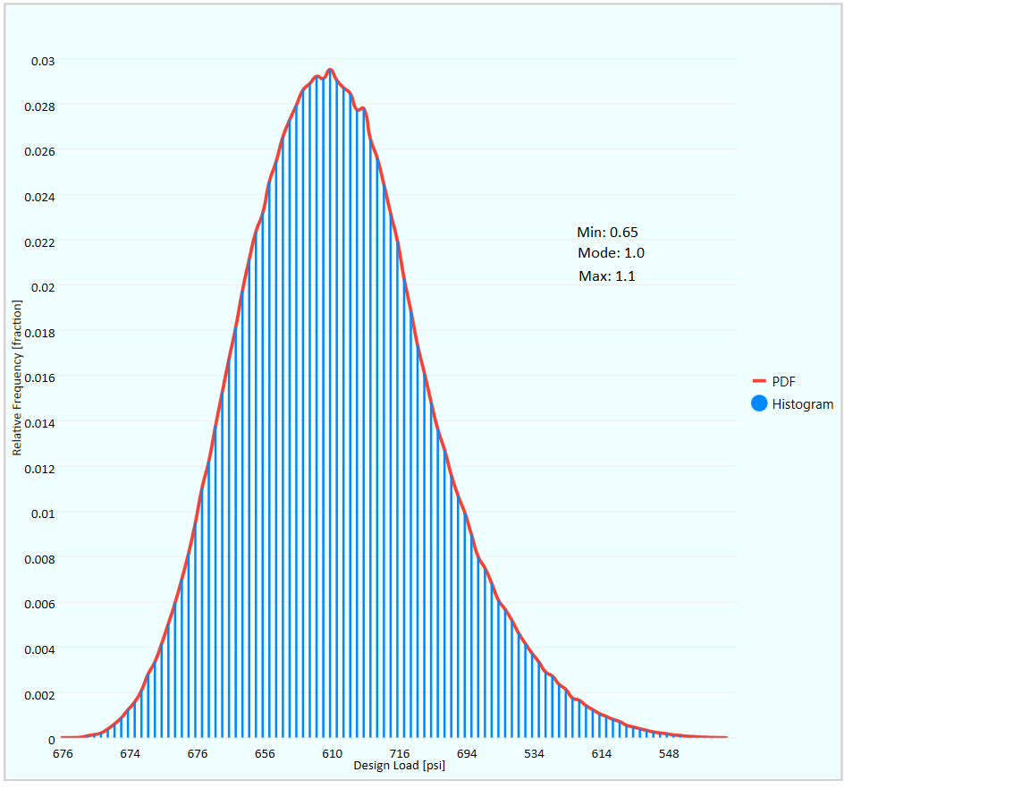 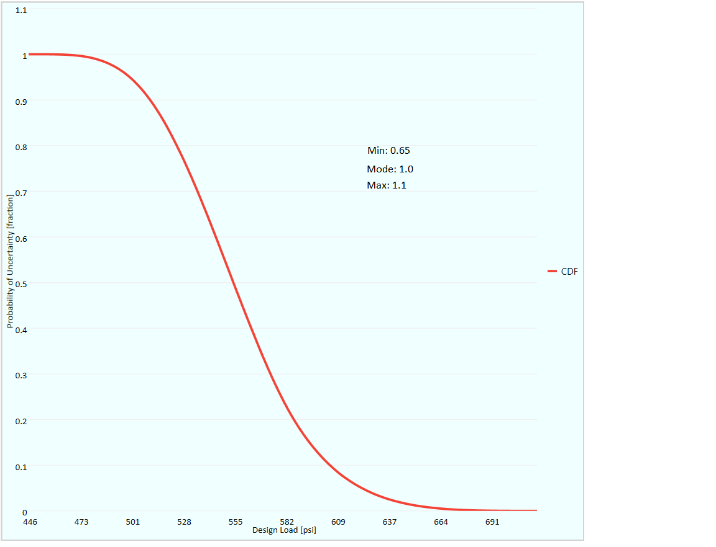

Figure 7. Burst design load with fitted PDF Figure 8. Burst design load with fitted CDF

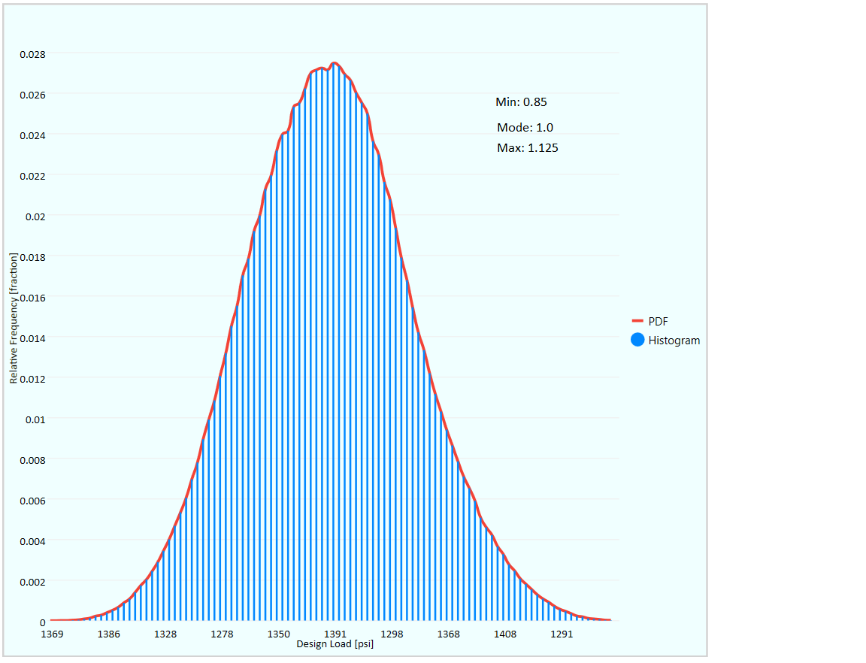 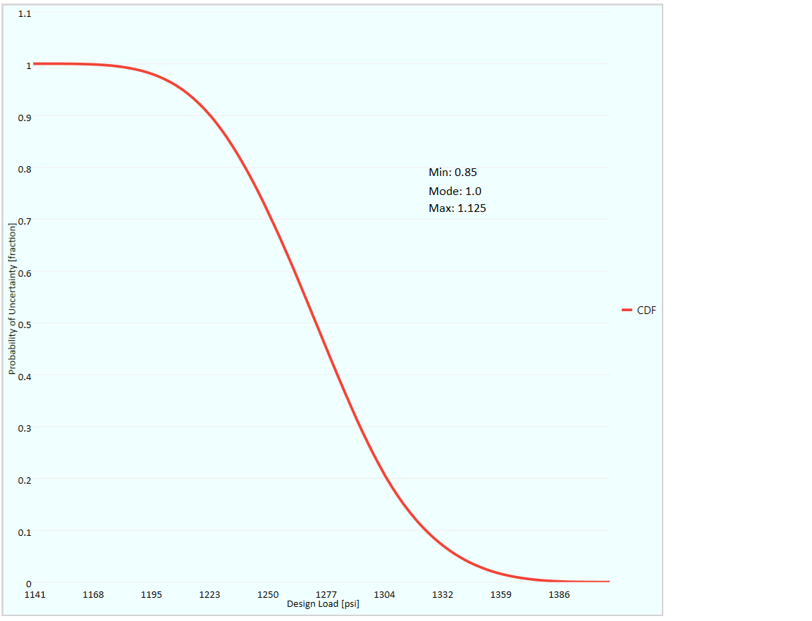

Figure 9. Collapse design load with fitted PDF Figure 10. Collapse design load with fitted CDF

Continous Uniform Distributions

Similar to triangular distribution. The design load followed a continuous uniform distribution. The confident interval of the design load is detailed in Table 3.

The visual inspection of the PDF and CDF plots suggest a uniform distribution is representative of the design load. However, the plot shown in Figure 11 and 13 were highly linear with only slight deviations at the top.

Table 3: Summary of burst and collapse loads for uniform distribution

|  |  |  |  |  |  |
| --- | --- | --- | --- | --- | --- |
|  | | Burst load | | Collapse load | |
|  | | Surface | Casing shoe | Surface | Casing shoe |
| Depth (ft) | |  | 3000 |  | 3000 |
| External load (psi) | | 0 | 1342 | 0 | 1342 |
| Internal load (psi) | | 1728 | 2028 | 0 | 0 |
| Net load (psi) | | 1728 | 686 | 0 | 1342 |
| Working stress design load (psi) | | 1901 | 755 | 0 | 1342 |
| Probability  (Confident interval ) | P90 (psi) | 1745 | 693 |  | 1359 |
| P50 (psi) | 1813 | 720 |  | 1426 |
| P10 (psi) | 1882 | 747 |  | 1491 |

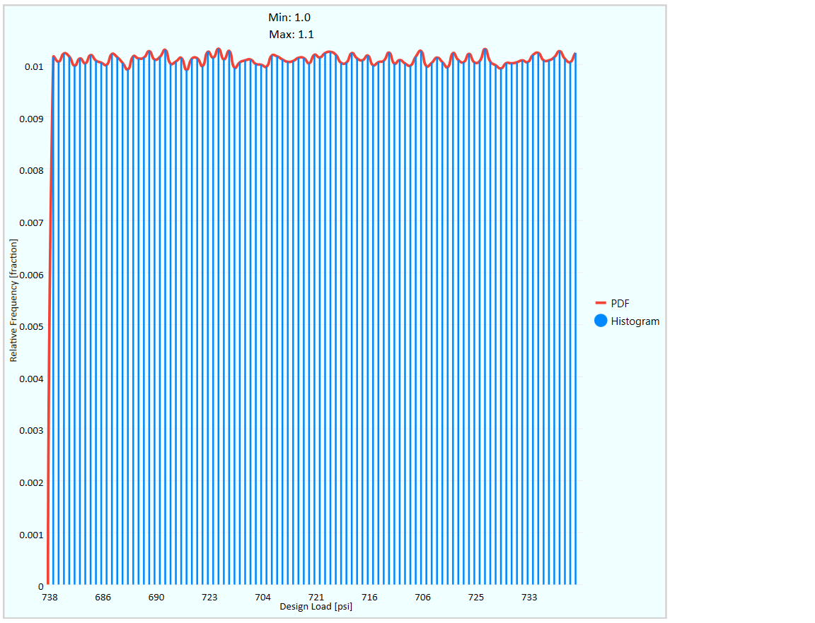 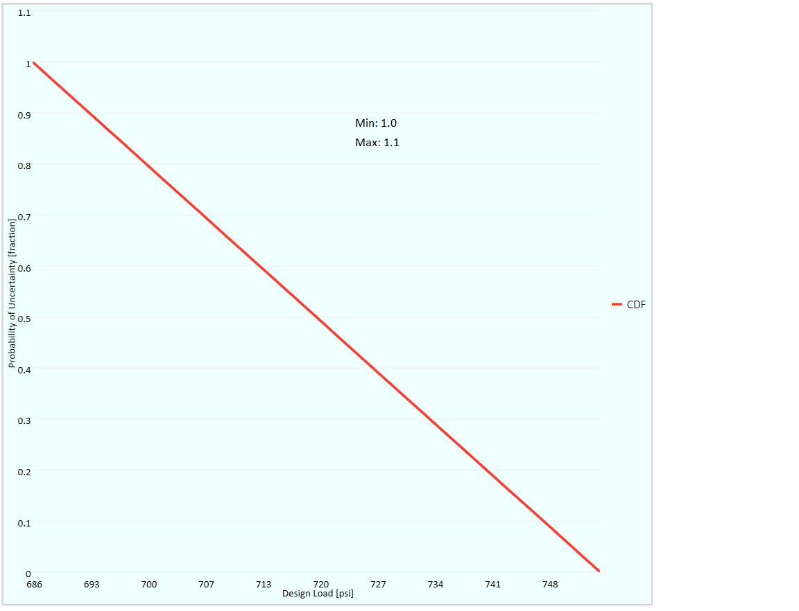

Figure 11. Burst design load with fitted PDF Figure 12. Burst design load with fitted CDF

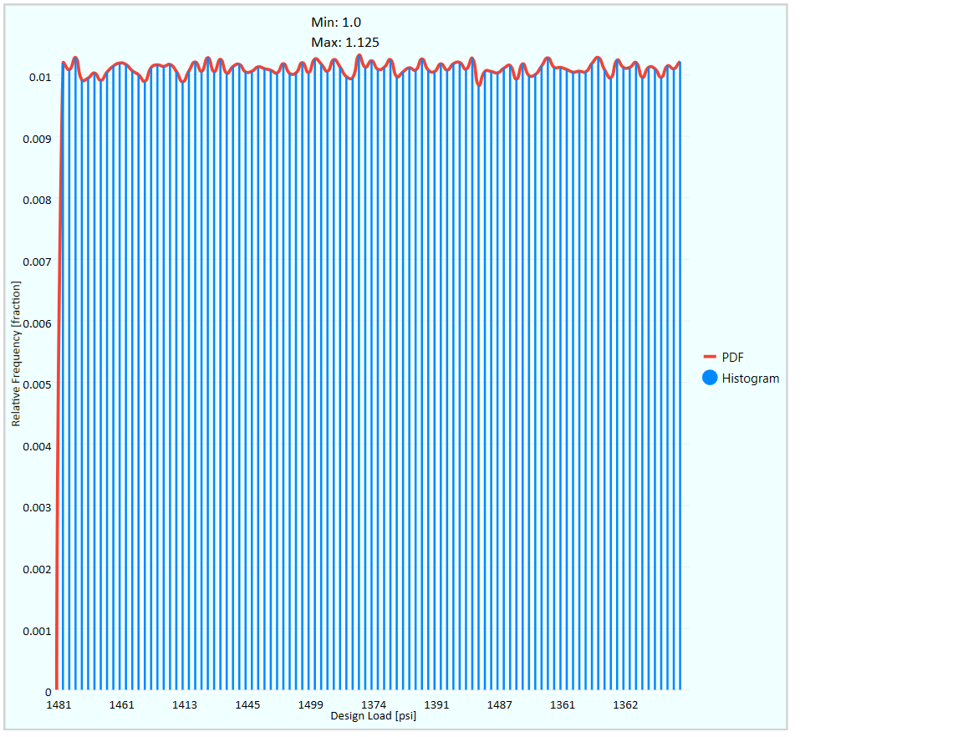 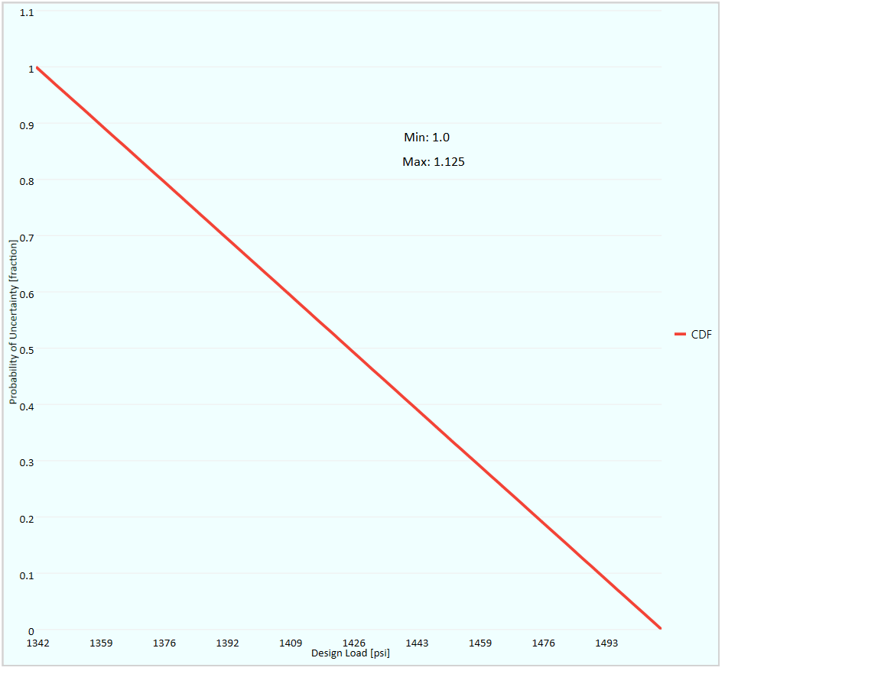

Figure 13. Collapse design load with fitted PDF Figure 14. Collapse design load with fitted CDF

Triangular vs. Uniform Distributions

Design load statistical values could be best represented by uniform or triangular distribution with the goodness of fit test supporting the visual PDF and CDF plots. The triangular distribution had difficulty fitting low values of simulated design load without applying goodness of fit test to the dataset.

Uniform distribution was the best performing in regards to low simulation values, while triangular distribution was a poor representative of the low simulation values.

Although the uniform distribution performed well with low simulation values, the triangular distribution outperformed it in the goodness of fit tests, as well as providing a visibility

Deciding on which distribution to choose is based on the uncertainty in the variable(s) that affect the design load. Uniform distribution should be chosen, where all values have an equal chance of occurrence.While Triangular distribution should be chosen, where values around the most likely (mode), can be defined together with the minimum and maximum values.

Conclusions and Future Work

Several distributions provide confidence in the modeling of the statistical properties of the design load. The probability (p-value) obtained through this method indicates the probability of uncertainty of a casing, as it explicitly considers the randomness of the design variables and parameters. The p-value is crucial in the determination of the real uncertainty involved in the design, with a low value (below the significance level) suggesting that the design load distribution is underestimated. The selection of the best design load can be made upon by a combination of the p-value, the confidence interval and visual inspection of the PDF and CDF fit in the simulation plots. This method is largely dependent on the number of iterations of the random variable. Large simulation data affects the performance of the plots as there are a large number of data points, especially at the tails of the distribution, which greatly affect the visual inspection of the CDF.

An essential advantage of the probability approach to casing design is its ability to provide a better view of the real uncertainties involved in the design. The MCS, in particular, may provide insights into the casing failure modes including its main design load range. The use of this information may aid in selecting an optimized casing design load based on the cost and operating conditions the casing will undergo. With the selection of design load based on cost, the economic analysis aspects have not been considered in this study and are worth future investigation.

References

1. PetroWiki. (2015, 06 25). *Casing and Tubing*. Retrieved from PetroWiki: https://petrowiki.org/Casing_and_tubing
2. Alade, O. (2018). Relevant Information on Oil and Gas Casing Design. ResearchGate, 1.
3. Chantose, P. J. (2011, 12). Structural Reliability: Assessing the Condition and Reliability of Casing in Compacting Reservoirs. Retrieved from Texas A&M University: http://oaktrust.library.tamu.edu/bitstream/handle/1969.1/ETD-TAMU-2011-12-10406/CHANTOSE-THESIS.pdf?sequence=2
4. PetroWiki. (2015, 06 25). Risk-based Casing Design. Retrieved from PetroWiki: https://petrowiki.org/Risk-based_casing_design
5. Silvestri, S., Gasparini, G., Trombetti, T., & C., C. (2008). Statistical Analysis Towards the Identification of Accurate Probability Distribution Models for The Compressive Strength of Concrete. World Conference on Earthquake Engineering (p. 8). Beijing: WCEE.
6. Conte, J. P. (2001). Statistics, Probability and Reliability. Statistics, Probability and Reliability. San Diego, California, United States of America: University of California.
7. Lucas, P., Eduardo, T., Jorel Lopes, R., João, P., & William, L. (2014). Reliability Assessment of Well Casing Design based on a Triaxial Serviceability Limit State. XXXV Ibero Latin American Congress on Computational Methods in Engineering (p. 12). Fortaleza: ResearchGate.
8. Hassan, M. A. (n.d.). Casing Design using PDF (Probabilistic Distribution & Forecast). Retrieved from Scribd: https://www.scribd.com/document/282985544/Casing-Design-using-PDF-Probabilistic-Distribution-Forecast
9. Hualin, L., Zhichuan, G., & Gang, L. (2012). Quantitative Risk Assessment on Safety and Reliability of Casing Strength for Oil and Gas Wells . International Conference on Future Electrical Power and Energy Systems (p. 7). Qingdao : Elsevier.
10. Microsoft. (n.d.). Random. Retrieved from Microsoft Reference Source .Net Framework 4.8: https://referencesource.microsoft.com/#mscorlib/system/random.cs
11. Microsoft. (n.d.). Random Class. Retrieved from Microsoft Docs: https://docs.microsoft.com/en-us/dotnet/api/system.random?redirectedfrom=MSDN&view=netframework-4.8&viewFallbackFrom=netframework-4.8%2F
12. Palisade. (n.d.). Monte Carlo Simulation. Retrieved from Palisade: https://www.palisade.com/risk/monte_carlo_simulation.asp
13. Devereux, S. (2013, May 13). Casing Design Safety Factors. Retrieved from Spread Forum: https://my-spread.com/discussions/2892
14. Learning, L. (n.d.). The Uniform Distribution. Retrieved from Courses, Lumen Learning: https://courses.lumenlearning.com/odessa-introstats1-1/chapter/the-uniform-distribution/
15. Jennifer, L., & Jeffrey, P. (2015, June 9). Triangular Distributions and Correlations (The simple math behind triangular distributions and correlations in Monte Carlo simulations). Retrieved from Iceaaonline: http://www.iceaaonline.com/ready/wp-content/uploads/2015/06/RI08-Presentation-Lampe-Triangular-Distributions.pdf
16. Stephens, M. A. (1970). Use of the Kolmogorov-Smirnov, CramerVon Mises and Related Statistics Without Extensive Tables. Journal of the Royal Statistical Society. Series B (Methodological), vol 32(1), 115–122.
17. University, ITM. (2018). Casing Design Calculation. Retrieved from StuDocu: https://www.studocu.com/in/document/itm-university/chemical-engineering/tutorial-work/270984243-casing-design-calculation/3308756/view

Abbreviations

**WSD** Working Stress Design

**MCS** Monte Carlo Simulation

**SFs** Satey Factors

**SF** Safety Factor

**API** American Petroleum Institutes

**CDF** Cumulative Distribution Function

**PDF** Probability Density Function

Nomenclature

C# C Sharp

$ω$ Weighting function